IDEATION PHASE

BRAINSTORM

|  |  |
| --- | --- |
| DATE | 16 OCTOBER 2022 |
| TEAM ID | PNT2022TMID14113 |
| PROJECT NAME | IOT-BASED SMART CROP PROTECTION SYSTEM FOR AGRICULTURE |
| MAXIMUM MARKS | 4 MARKS |

<https://app.mural.co/invitation/mural/ibmteam6597/1666073909760?sender=uc1b75701e93438003d944244&key=619d40a4-c9db-43a2-ae8c-b712be92e639>

Step-1: Team Gathering, Collaboration and Select the Problem Statement

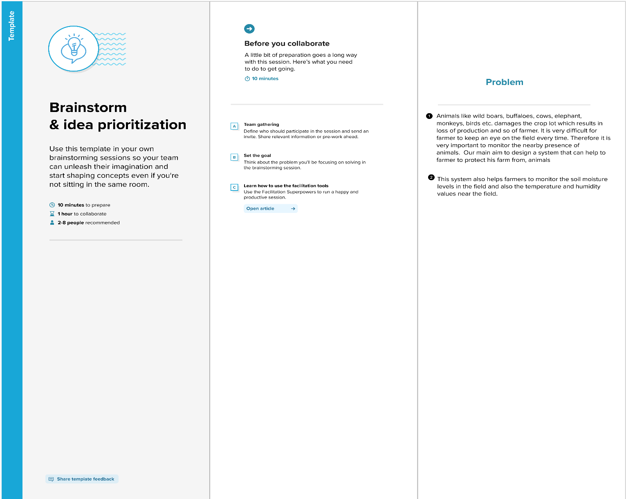

Step-2: Brainstorm, Idea Listing, and Grouping

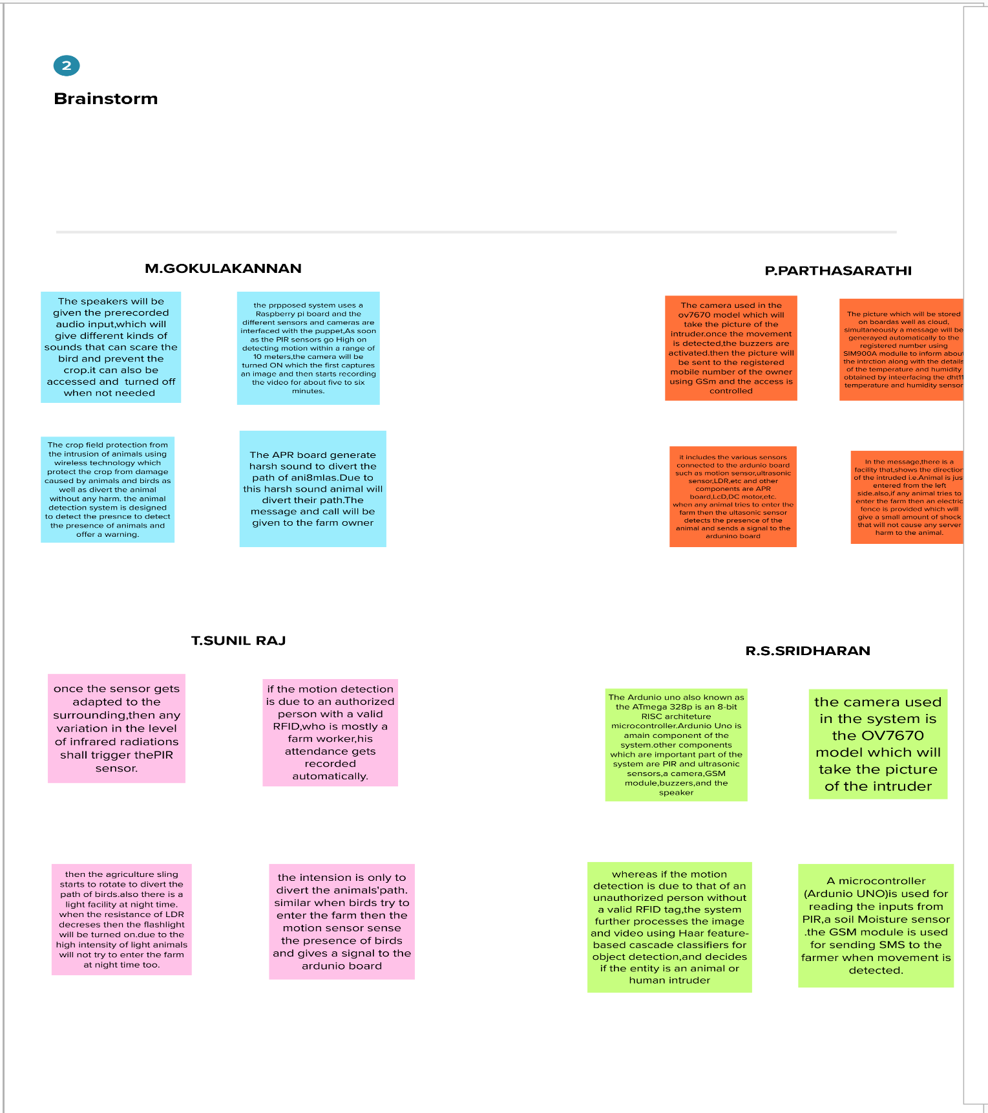

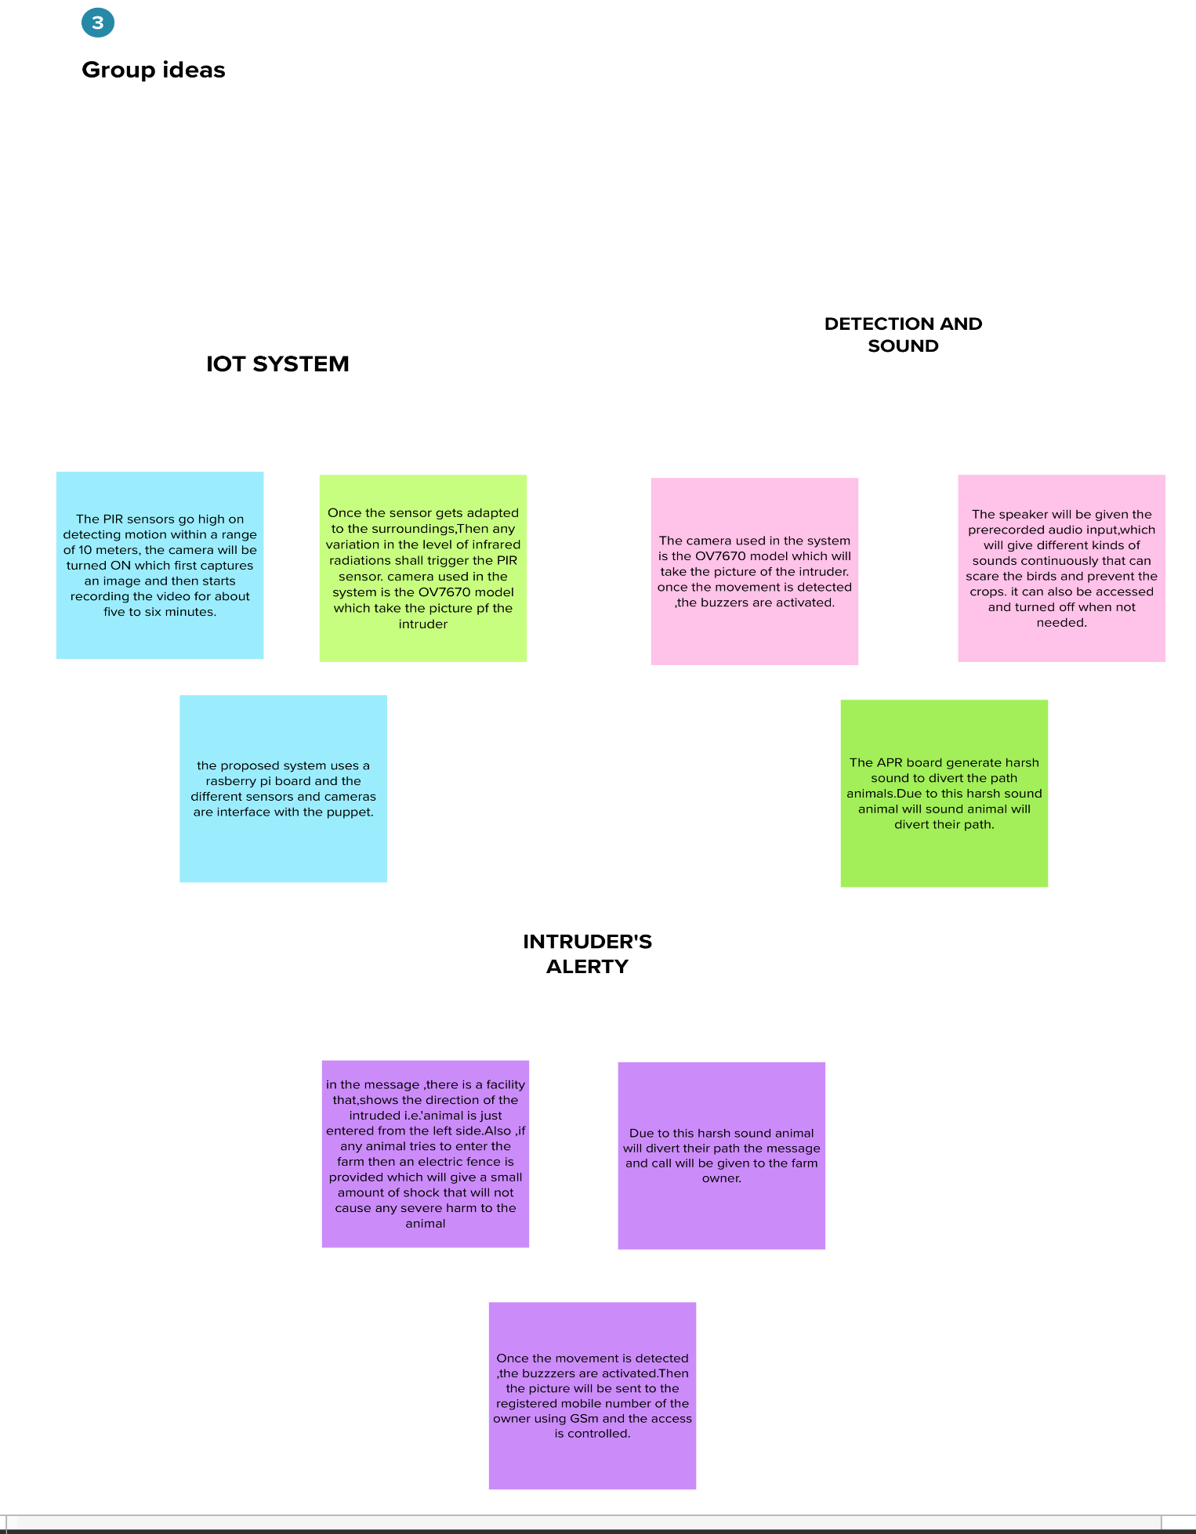

Step-3: Idea Prioritization

